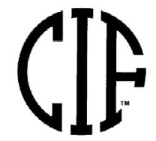

California Interscholastic Federation
Wrestling Championship
Official’s Nomination Form

Association Directors:
1. Please forward this template to qualified and recommended official in your association.
2. Have the official fill this out electronically and return to you electronically.
3. Association Director will forward this application and picture to their section commissioner.
4. The Section Commissioner will sign electronically and forward this form to Duane Morgan at dmorgan@cifccs.org

5. Applying for Boys or Girls or Both State Championships (circle one)

2 x 2 photo-jpeg format

gray official shirt

Must be sent in jpeg format

Send as an attached file along with this application

Due Date: December 1, 2017

Official’s Name:

E-mail Address:
Address:
City: Zip:
Home Phone: Cell Phone
Shirt & Jacket Size:
Which CIF Section are you representing:

Wrestling Experience (Competitor/Coach)

Officiating Experience (year, level, major tournaments)

References (with contact information):

Officials Association Director Information:

Name:

E-mail:

Home Phone:

Cell Phone:

Section Commissioner Signature (required-electronically if possible): Date:

